User Manual
How to share a file



How to Securely Share a File with SpecterX
Sharing files with SpecterX works the same way on each and every platform. SpecterX integrates with your existing tools and apps to provide you with a seamless experience, while maintaining all of the preset security features.

Here are just a few examples:

Outlook
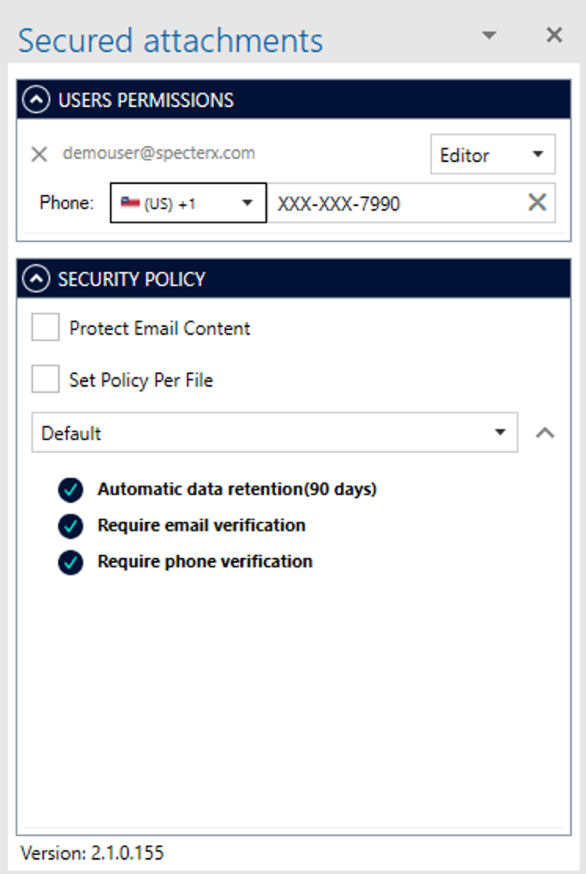

SpecterX Web Platform
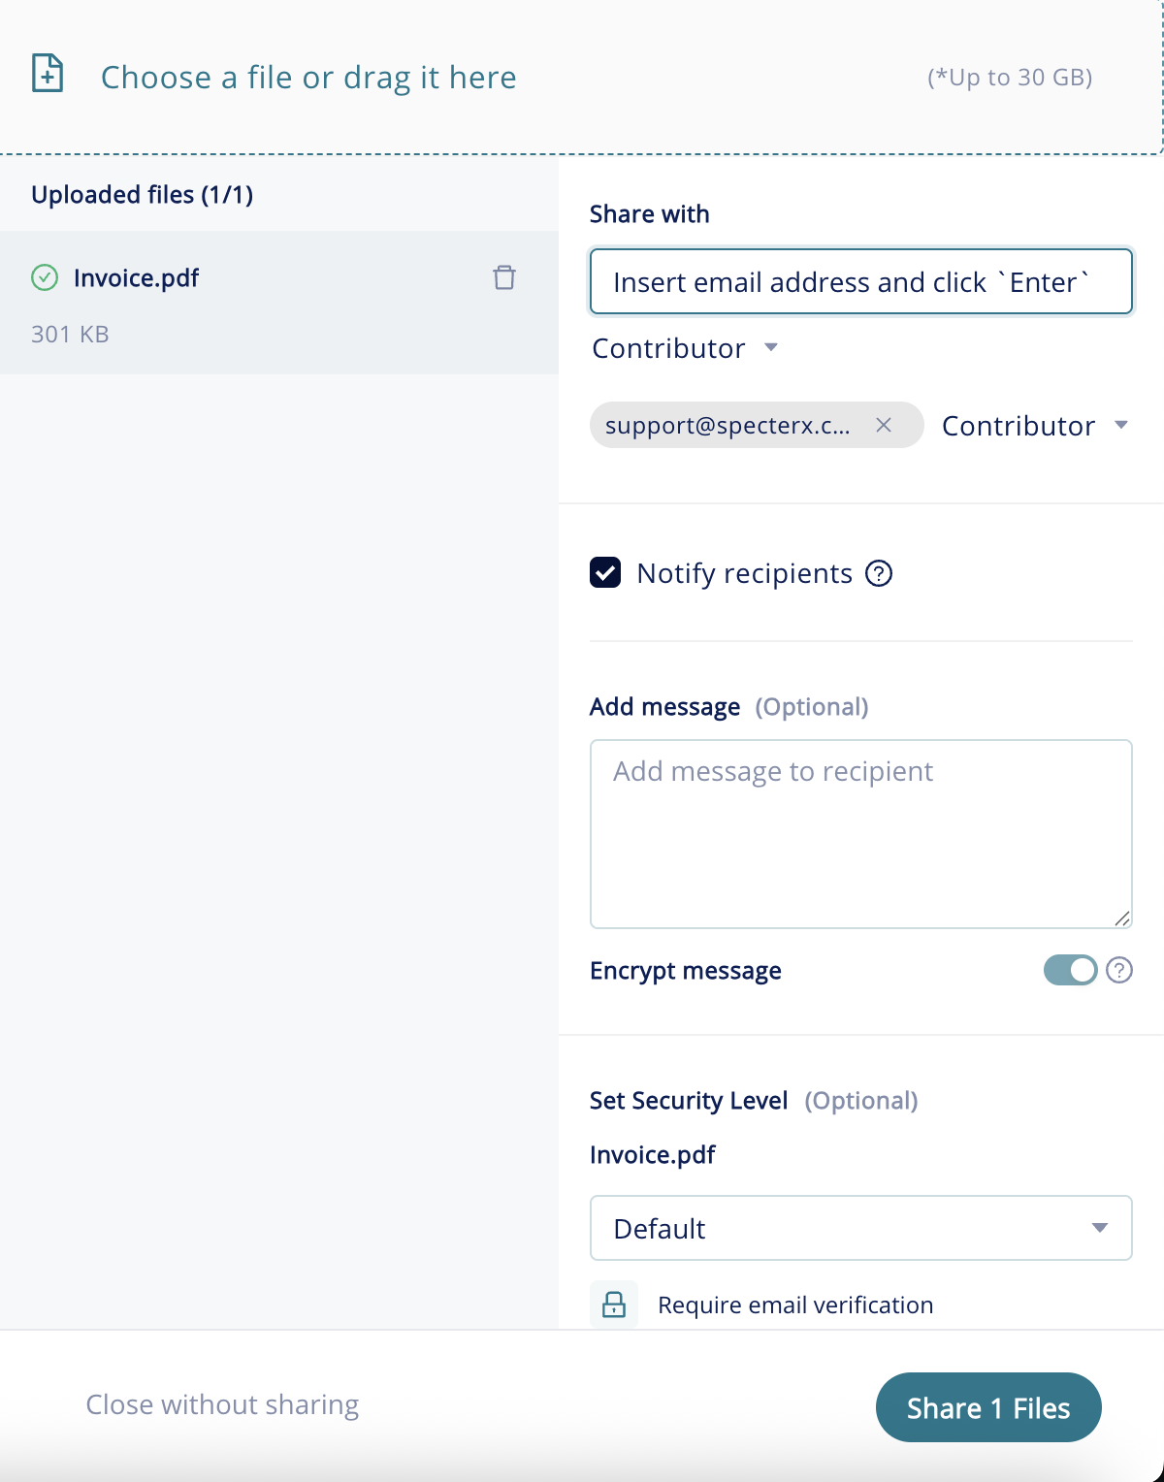

Gmail
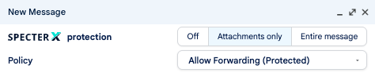

Sharing a File Securely from Outlook

Install the SpecterX Outlook Add-in
Installing the Add-in is extremely easy.
If your system administrator hasn’t installed the Add-in for you yet, download the Add-in MSI file or ask your administrator to send you a copy. Once you receive it, double-click it and follow the instructions within the installer.
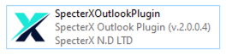

Protecting an Email
Now that you have the SpecterX Outlook Add-in installed it’s time to share a file!
In the Outlook top menu bar, you’ll see a new icon: SpecterX - Enable Protection
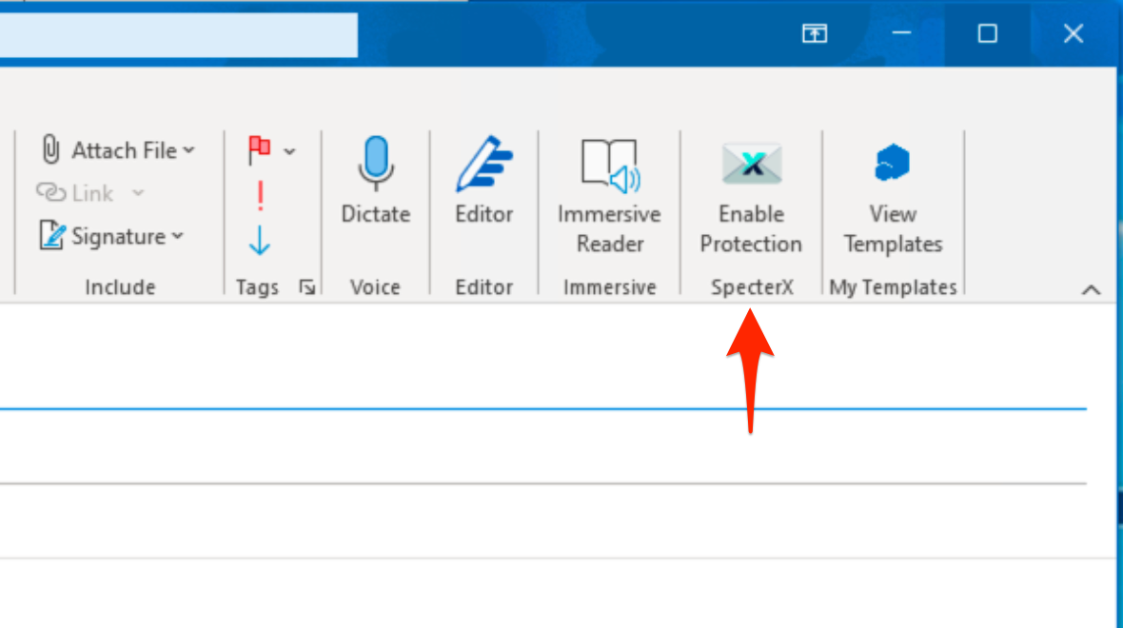
To share a file securely, write the list of recipients in the "To" / "Copy" fields (if necessary) and attach files, as you would normally.
Once done, click on the ‘Enable Protection’ button.

The SpecterX Outlook Add-in menu will open on the right side of the window.
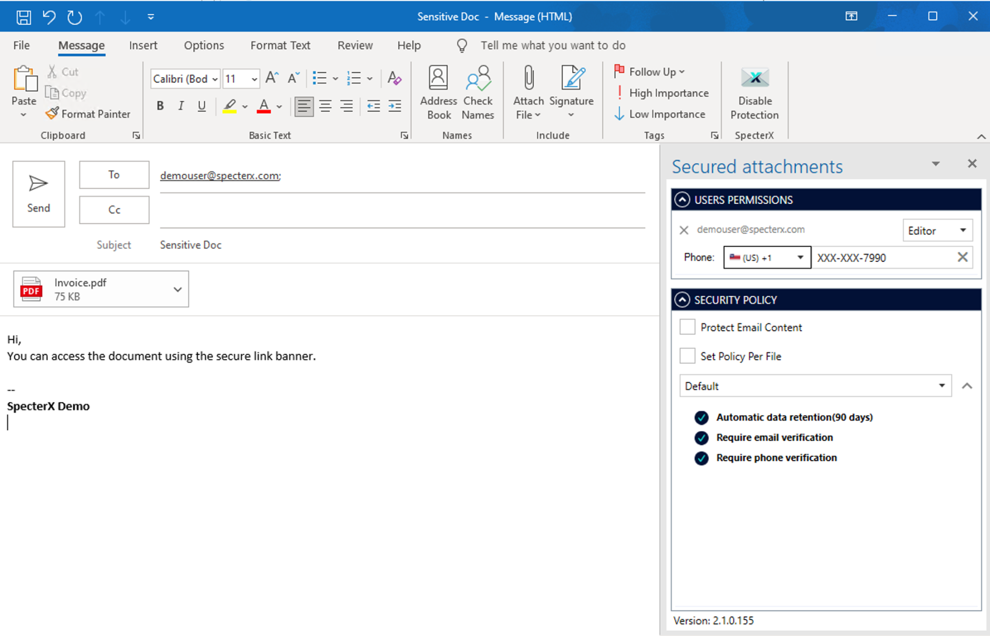

For each of the recipients added to the ‘To’, ‘CC’, and ‘BCC’ fields, you can choose the level of permissions they will have over the attached files.
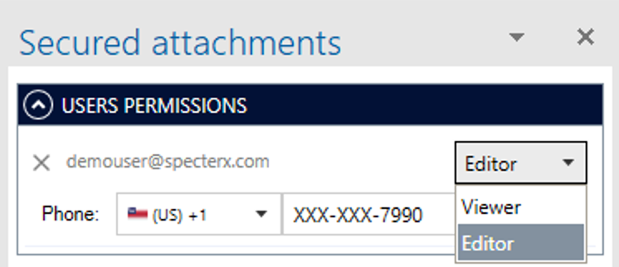

SpecterX allows you to protect the email content (email body and subject), as they also can include sensitive information. To do so, check the ‘Protect Email Content’ checkbox.
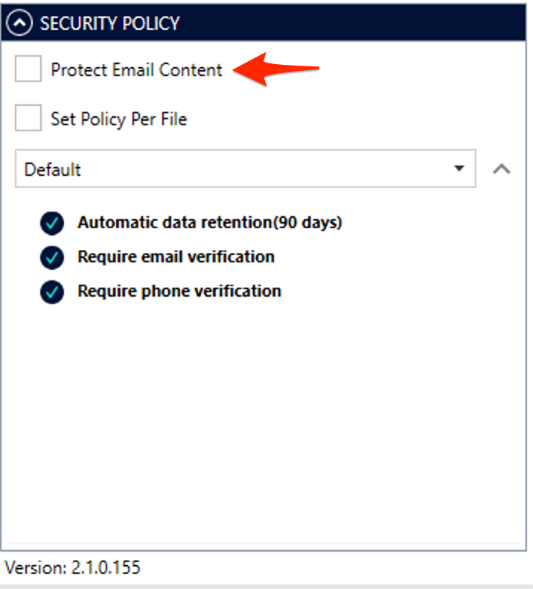

You can also choose a security policy for each file to match the file’s degree of security. Change policies by clicking the dropdown menu, or keep the Default policy assigned by the system admin.
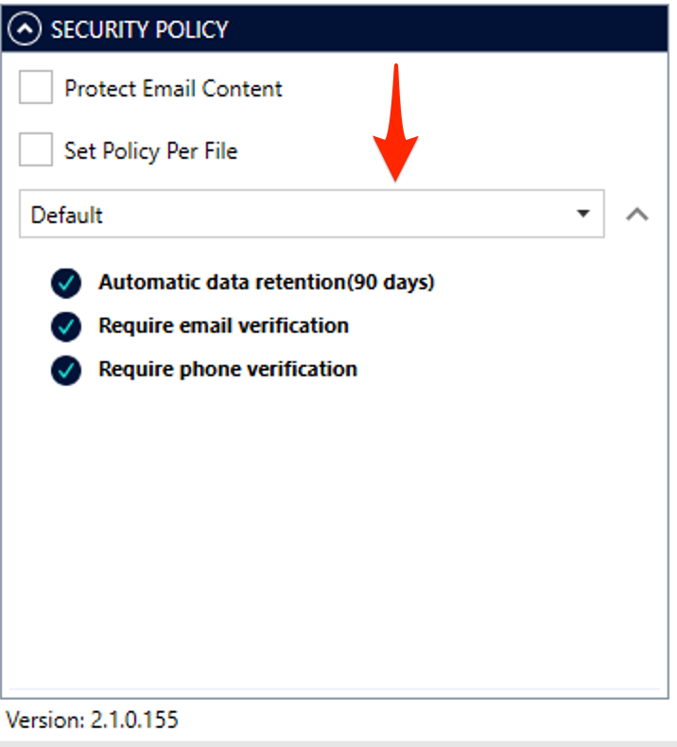

In case a policy that requires recipient verification over the phone (Phone Verification) was chosen. You will be prompted to fill in the recipient's phone number.
You can use this section to associate a phone number for an existing recipient or update it in case it's required.

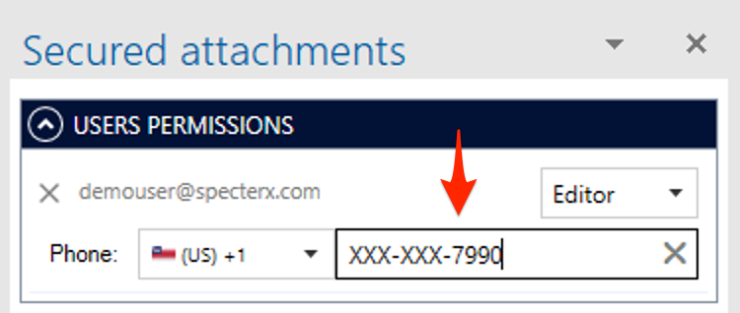

That’s it! You can now send your email, knowing your sensitive information is secured.

Sharing a File Securely from Gmail

Install SpecterX Gmail extension
If your system administrator hasn’t installed the extension for you, you can do it manually:
- Open the Google Workspace Marketplace and search for ‘SpecterX Gmail Extension’, click Install and follow the on-screen instructions
- Alternatively, ask your administrator to provide the installer file, then double-click it and follow the installation prompts.

Add image from marketplace

Protecting an Email
Now that you have the SpecterX Gmail extension installed it’s time to share a file!
Compose new email, in the top of the “New Message” window, you’ll see a new section: SpecterX - Protection
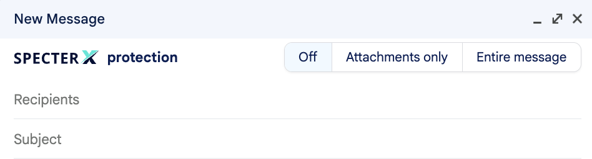
To share a file securely, write the list of recipients in the "To" / "Copy" fields (if necessary) and attach files, as you would normally.

Once done, select which part you want to secure- both the message and the attachments or only the attachments.
Once selected the preferred option, you’ll be able to select which security policy protects your data.
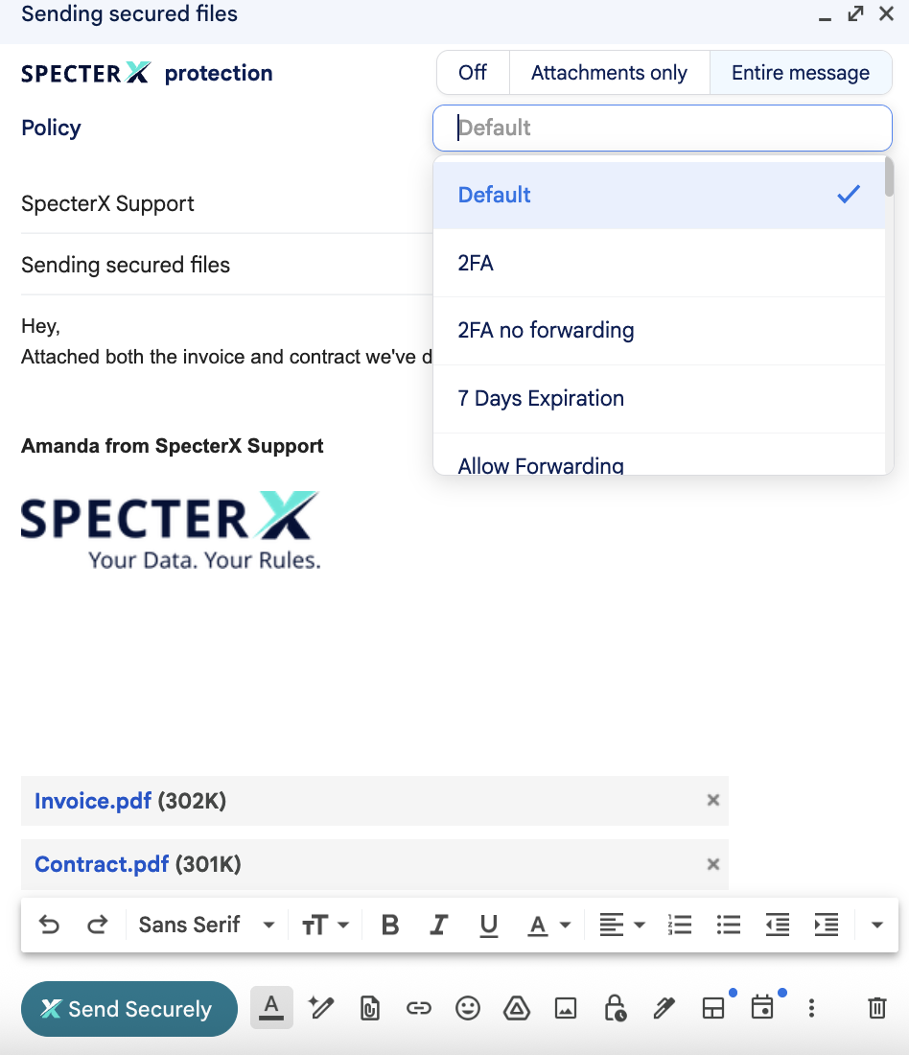

For each of the recipients added to the ‘To’, ‘CC’, and ‘BCC’ fields, you can choose the level of permissions they will have over the attached files.
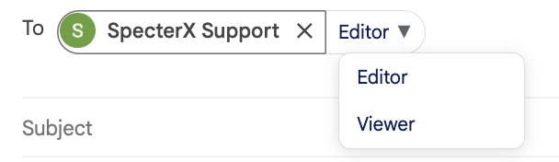

That’s it! You can now send your email, knowing your sensitive information is secured.

Sharing files Securely from SpecterX Web Platform

Logging in to the SpecterX web platform
In your browser, visit the SpecterX web app at https://your-org.specterx.com.

The identification process will be completed using your corporate identity.

Sharing a file
Click the ‘Share files’ button, placed at the right-hand side of the screen
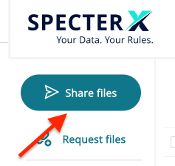

Drag your file/folder to the gray box or click on the box and select the files you would like to share

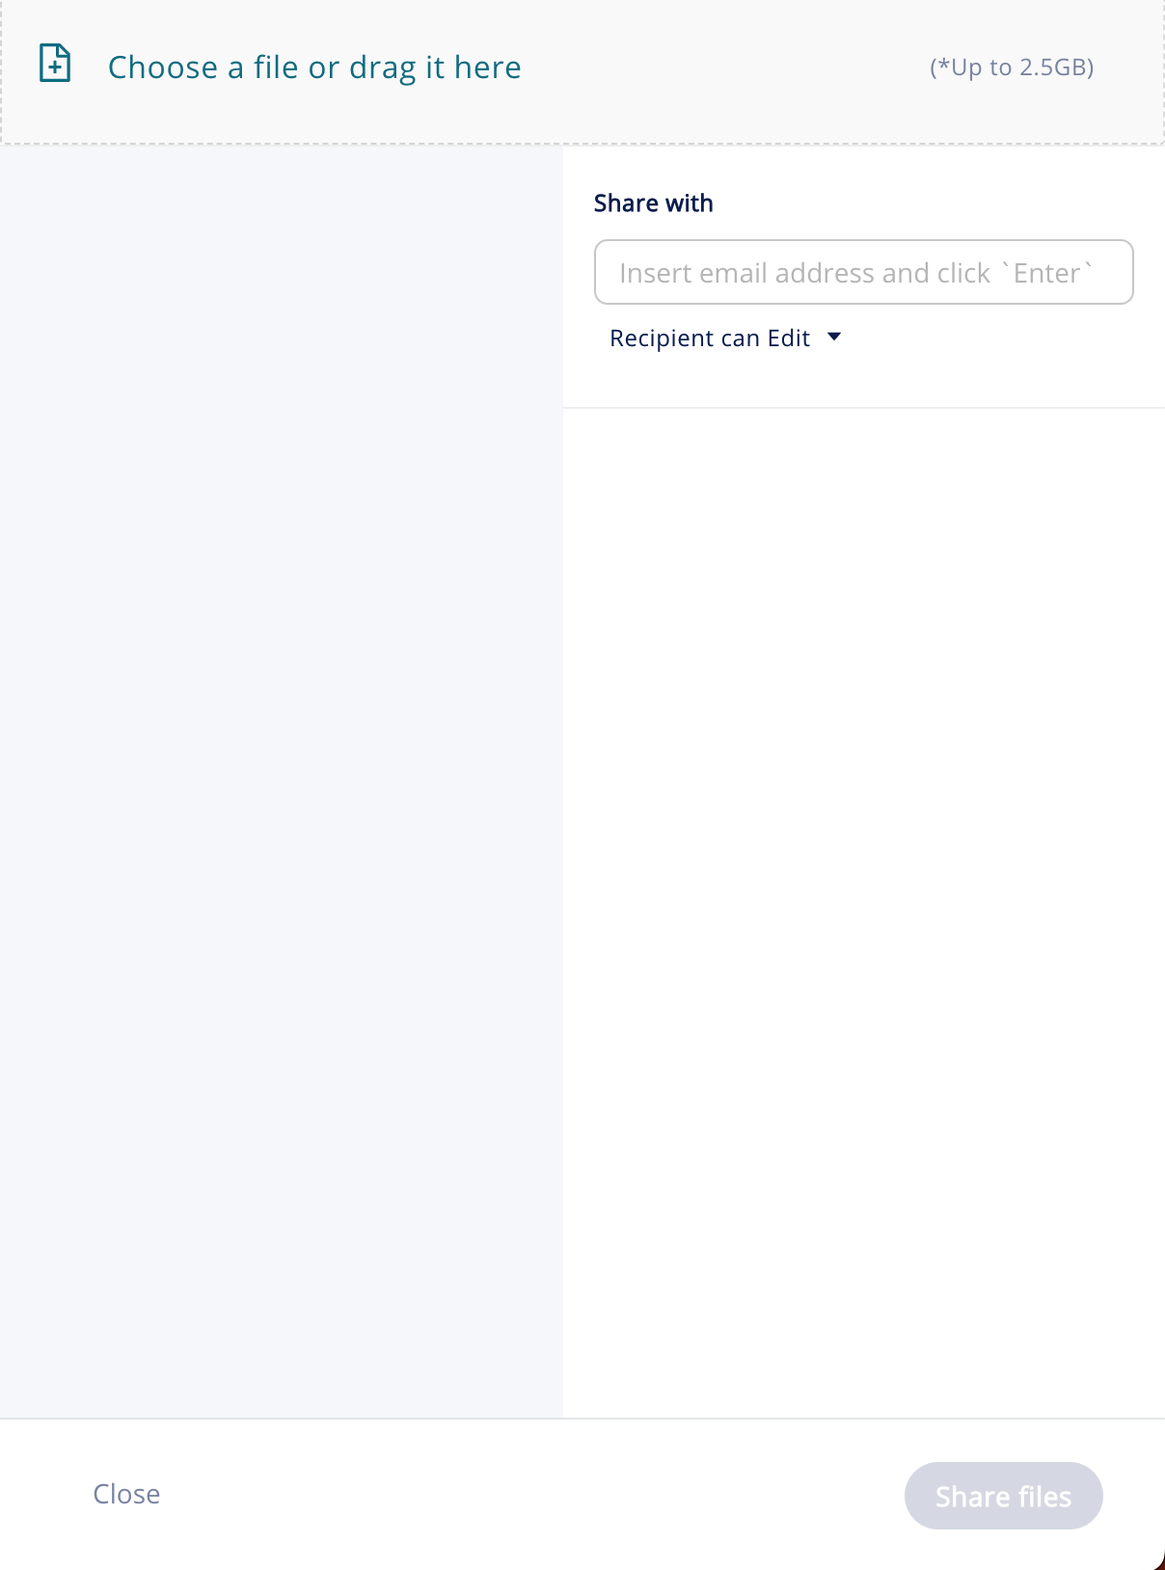
After choosing the files you would like to share, you’ll see an uploading progress bar. The file is now being uploaded to the organization's secure storage. This process will be complete once the progress bar turns green and reaches 100%.

Enter the recipient email address under the ‘Share with’ section and click Add, or click the ‘Enter’ button on your keyboard.
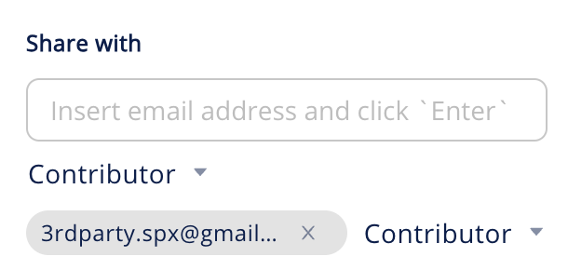

You can change the recipient’s usage permissions within the ‘Contributor’ dropdown and choose if the recipients will receive an email notification from SpecterX
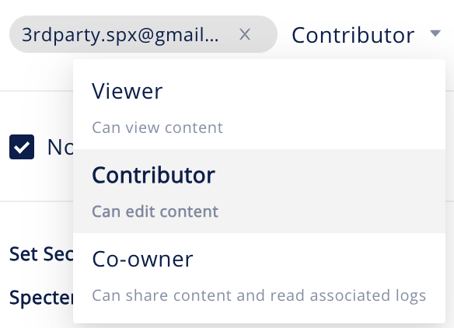

You can adjust the predefined policy for each file to determine how recipients will access and use the data
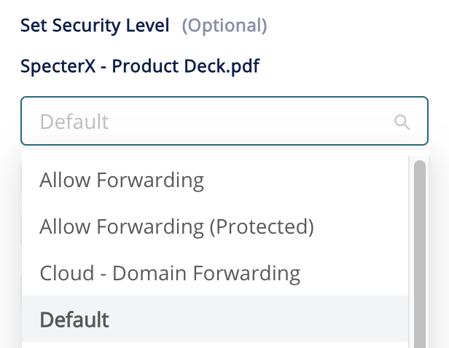

You can choose to apply the policy for the entire files/folders you uploaded by clicking the “Set for all” button

In order to share the file, click the ‘Share Files’ button at the bottom right corner


That’s it! You have shared your files successfully.
You may also want to copy the sharing link by clicking the ‘Copy to clipboard’ button, and use the link in your emails and instant messages.

If at any point you need assistance, our team is always glad to help.
Find us at: support@specterx.com

